‘Five Years’ Pre-Show Information

Five Years is a theatre show. It is performed by Neal Pike and BSL interpreter, Sue Lee.

Neal will tell stories about his time at Foxwood Special Educational Needs School.

The show will last for about one hour.

The show takes place at Chapel FM Arts Centre

Inside the Theatre

The seating is old church pews in the radio theatre upstairs. You can sit on any of the pews.

There will be some spaces at the front for wheelchairs.

On the stage there will be nine chairs and a desk, set out like this:
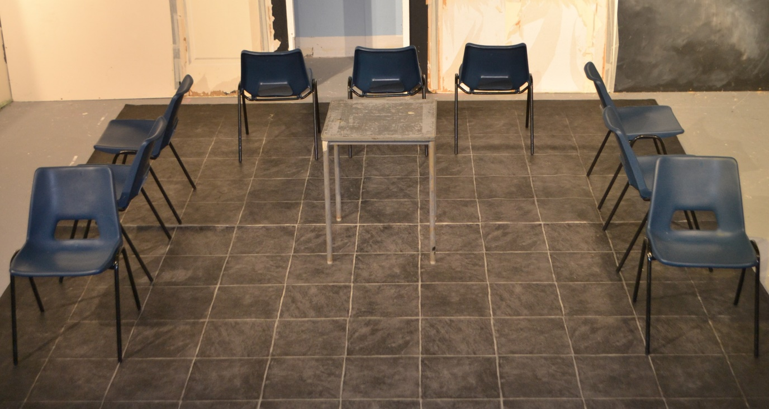

Before the performance starts, someone will stand up at the front and explain that this is a Relaxed Performance and what this means.

The Performance

The show will then begin. Some music will start playing and Neal will walk onto the stage.
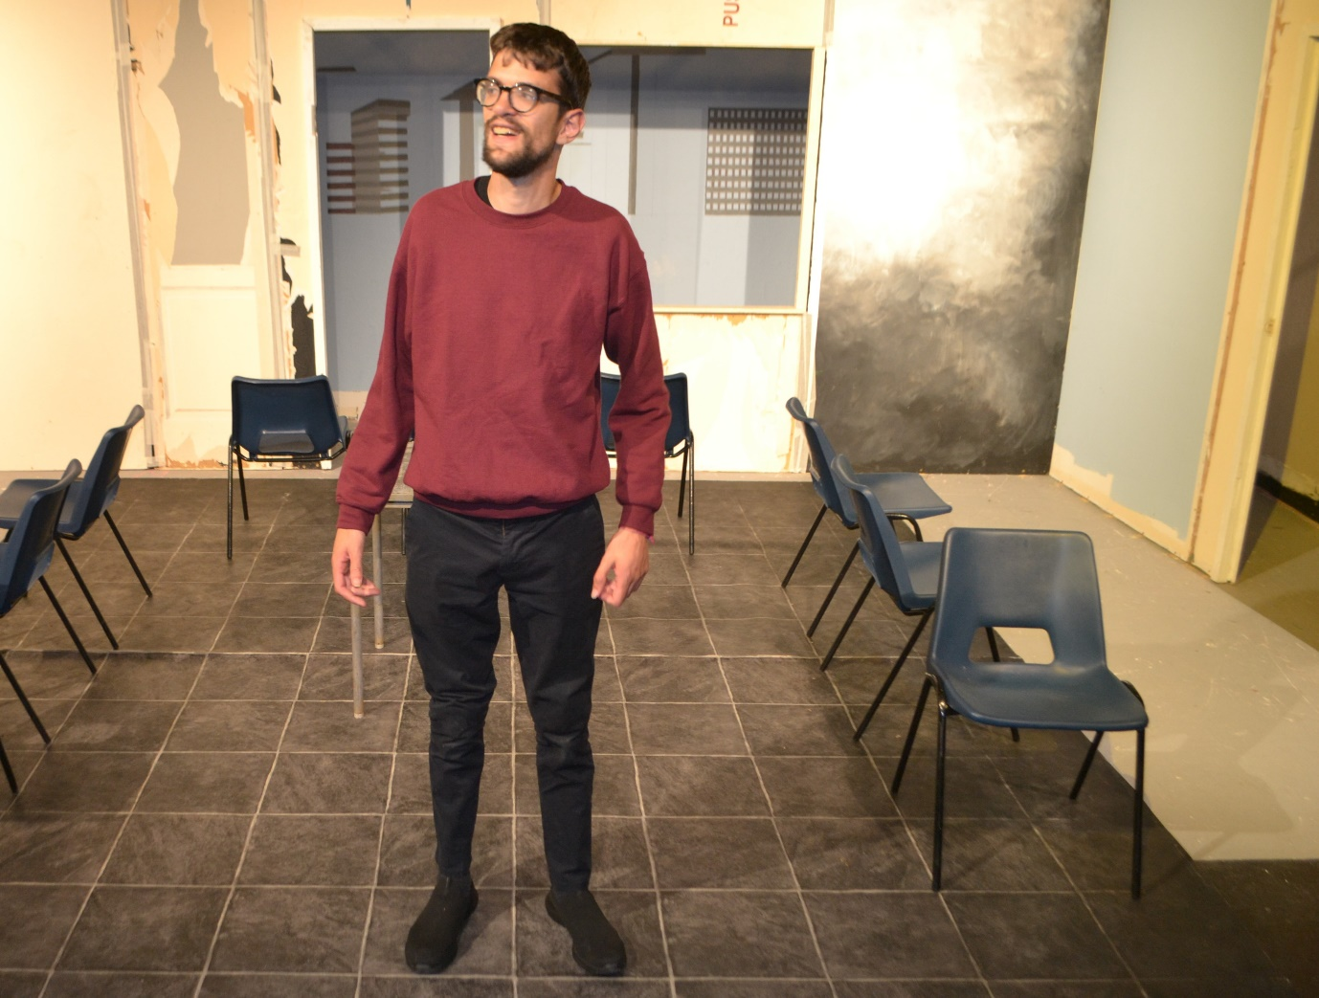

It is a Relaxed Performance, so you can make noise and move around as much as you want throughout the show.

During the performance you can leave the room if you want to and come back in at anytime.

You can ask a member of staff for ear defenders.

If you need to be somewhere quiet, a space will be available at (INSERT QUIET SPACE (and whether accessible))

During the show Neal will tell lots of stories about himself, school, his friends and family. Everything he says will be BSL interpreted. When he tells the stories, he moves about the stage and also moves the chairs and desk.

He picks up the chair once and holds it in the air.

At one point, Neal falls on the floor

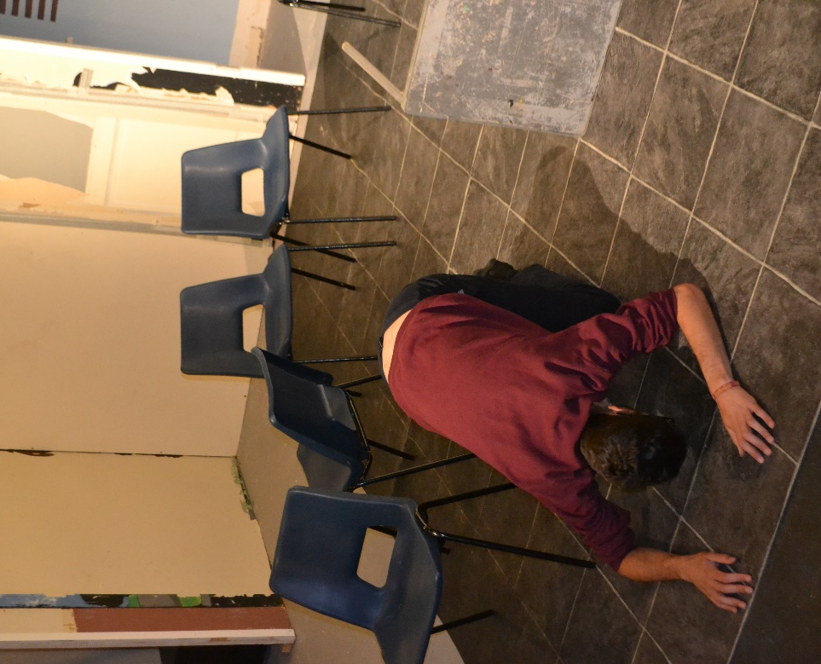
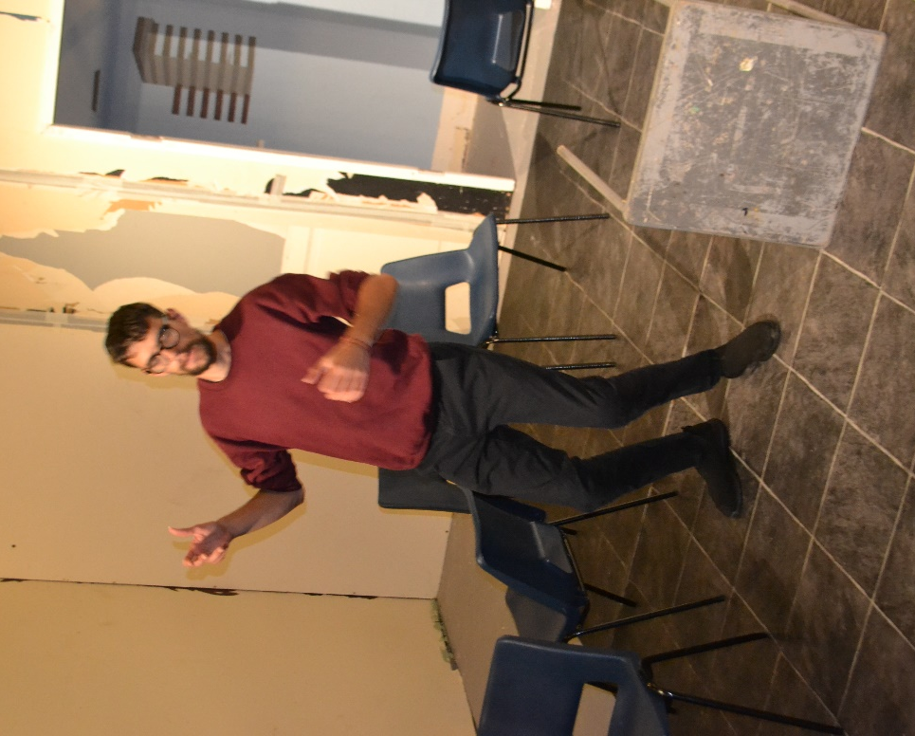

At two points, Neal stands on a chair

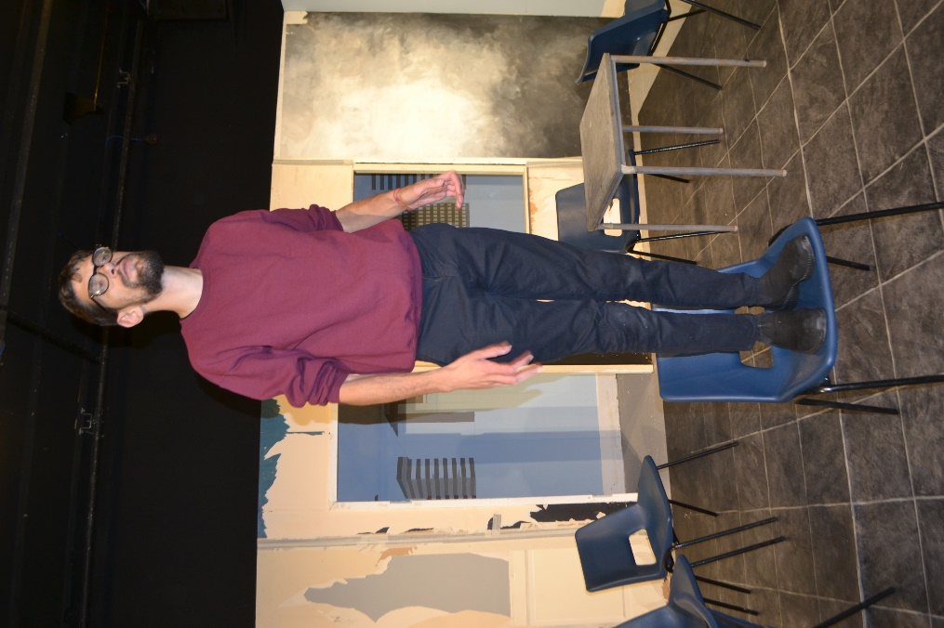
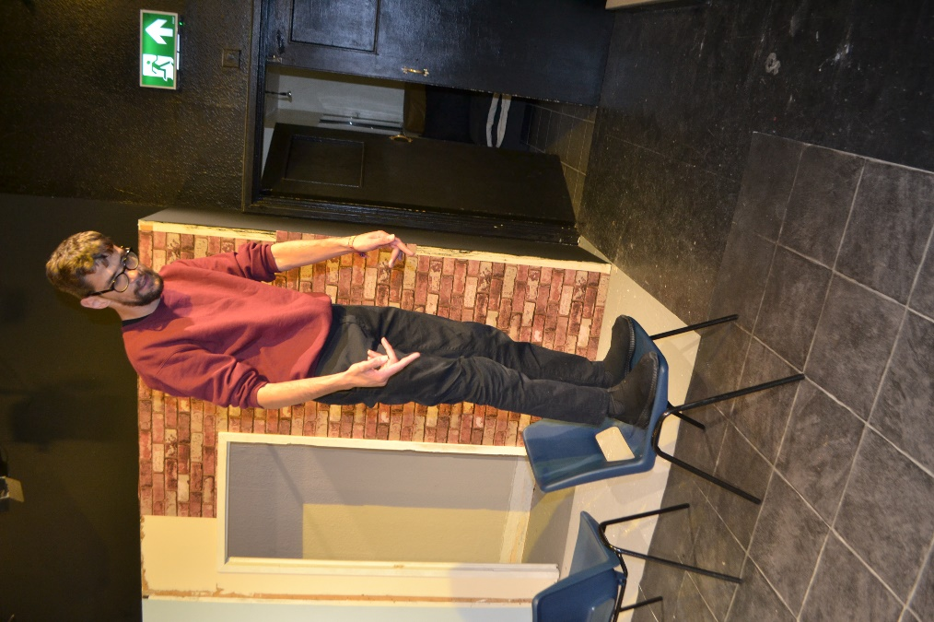

Neal will sometimes flip the table onto its side and hide behind it.

Sometimes, he will put his arms in the air quickly

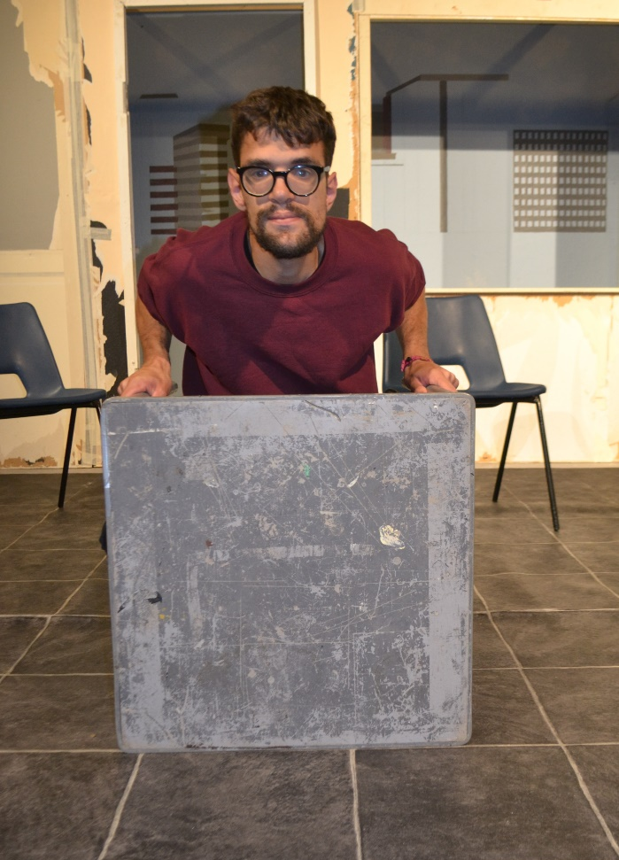

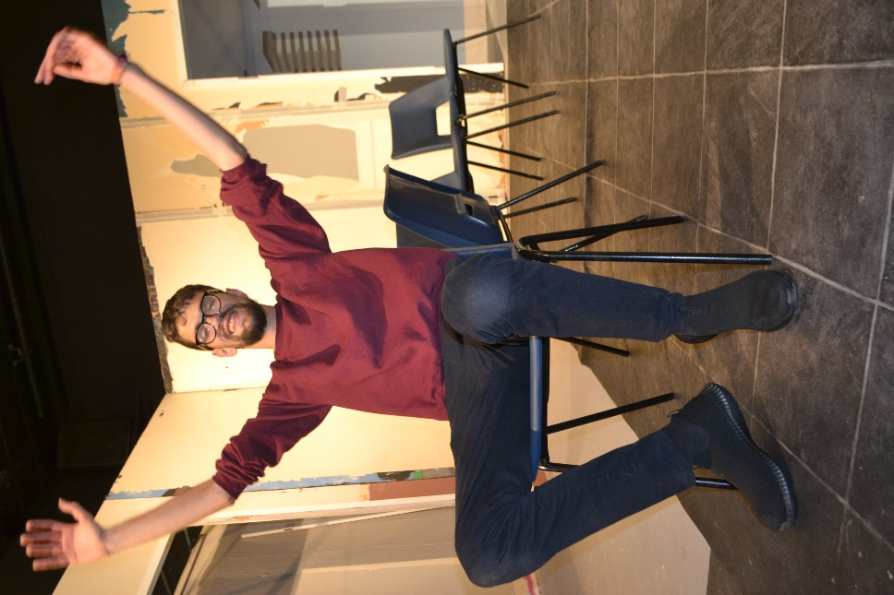

Lights

The lights on the stage will change throughout but will never go completely dark. So you will always be able to find your way to leave and come back to your seat if you want.

At two points, there will be video projections behind Neal of stars, clouds, and moving lines.

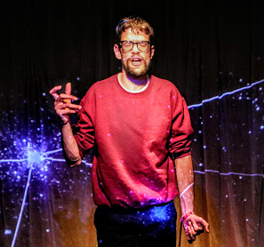

Loud Sounds

Sometimes Neal shouts loudly. There are sudden sound effects during the show, like the sound of a playground and the sound of a paintball gun firing.

There is also music at various points during the show.

When the performance is finished the audience will clap.

You can ask a member of staff for ear defenders at any time.

Content/Trigger Warning

Contains some strong language and references to bullying
Age Guidance 14+
Access Considerations

- The venue is wheelchair accessible.
- The performance is a Relaxed Performance – you can make noise and move around.
- You can go in and out of the show when you want.
- The show is BSL interpreted.
- Ear defenders are available.
- There will be a quiet space available in the café or a meeting room nearby if you prefer
- Please contact Adrian Sinclair- adrian@headstogether.org you have any access requests.

